Student Management System

(Student Management)

Lok Jagruti Kendra University

(LJ)



Developed By:

|  |  |  |
| --- | --- | --- |
| 1. | Malek Burhaan | 21018501210027 |
| 2. | Shaikh Mohd Arsh | 21018501210060 |
| 3. | Sheth Mahamad Sarjil | 21018501210061 |

Group No: -

Under the Guidance of:

Prof. Harsh Shah

Submitted To:

**L.J. INSTITUTE OF COMPUTER APPLICATION**



**L.J. INSTITUTE OF COMPUTER APPLICATIONS**

**Sarkhej Road, S.G. Highway, Ahmedabad**



# ***CERTIFICATE***

**Enrolment No: 195170686032 Seat No: _____________**

This is to certify that **Mr. Malek Burhaan** of Integrated Master of Computer Applications, Semester 8 has satisfactorily completed his Project titled **E-Learning Management System** under the supervision of **ProfHarsh.**

**Internal Guide Name: Signature**

Prof Harsh

**Date of Submission:**

29-04-2023

**L.J. INSTITUTE OF COMPUTER APPLICATIONS**

**Sarkhej Road, S.G. Highway, Ahmedabad**



# ***CERTIFICATE***

**Enrolment No: 195170686029 Seat No: _____________**

This is to certify that **Mr. Shaikh Mohd Arsh** of Integrated Master of Computer Applications, Semester 8 has satisfactorily completed his Project titled **E-Learning Management System** under the supervision of **Prof Harsh**

**Internal Guide Name: Signature**

Prof Harsh

**Date of Submission:**

29-04-2023

**L.J. INSTITUTE OF COMPUTER APPLICATIONS**

**Sarkhej Road, S.G. Highway, Ahmedabad**



# ***CERTIFICATE***

**Enrolment No: 195170686005 Seat No: _____________**

This is to certify that **Mr. Sheth Mahamad Sarjil** of Integrated Master of Computer Applications, Semester 8 has satisfactorily completed his Project titled **E-Learning Management System** under the supervision of **Prof Hasrh**

**Internal Guide Name: Signature**

Prof Harsh

**Date of Submission:**

29-04-2023

|  |  |  |
| --- | --- | --- |
| Sr. No. | TABLE OF CONTENTS | Page No. |
| 1. | INTRODUCTION | 6 |
|  | 1.1 Existing System | 6 |
|  | 1.2 Need for the New System | 6 |
|  | 1.3 Objective of the New System | 7 |
|  | 1.4 Problem Definition | 7 |
|  | 1.5 Core Components | 7 |
|  | 1.6 Project Profile | 8 |
|  | 1.7 Assumptions and Constraints | 8 |
|  | 1.8 Advantages and Limitations of the Proposed System | 9 |
| 2. | REQUIREMENT DETERMINATION & ANALYSIS | 10 |
|  | 2.1 Requirement Determination | 10 |
|  | 2.2 Targeted Users | 10 |
|  | 2.3 Timeline Chart | 11 |
| 3. | SYSTEM DESIGN | 12 |
|  | 3.1 Use-Case | 12 |
|  | 3.2 Class Diagram | 15 |
|  | 3.3 Interaction Diagram | 16 |
|  | 3.4 Activity Diagram | 23 |
|  | 3.5 Data Dictionary | 28 |
| 4. | DEVELOPMENT | 32 |
|  | 4.1 Coding Standard | 33 |
|  | 4.2 Screenshots | 35 |
| 5. | AGILE DOCUMENTATION | 36 |
|  | 5.1 Agile Project Charter | 38 |
|  | 5.2 Agile Project Road / Schedule | 39 |
|  | 5.3 Agile Project Plan | 40 |
|  | 5.4 Agile User Story | 41 |
|  | 5.5 Agile Release Plan | 42 |
|  | 5.6 Agile Spring Backlog | 43 |
|  | 5.7 Agile Test Plan | 44 |
|  | 5.8 Earned Value & Burned Charts | 45 |
| 6. | PROPOSED ENHANCEMENTS | 49 |
| 7. | CONCLUSION | 50 |
| 8. | BIBLIOGRAPHY | 50 |

## 

## **1. Introduction:**

The Student Management System (SMS) is a modern and efficient solution for managing various student-related activities within educational institutions. It streamlines processes such as attendance tracking, marks management, progress monitoring, and result generation, all through a centralized platform. Students can securely access their results, download academic records, and monitor their progress by entering their enrollment number. This ensures transparency and accessibility for every user.

Administrators benefit from a simplified process to post results, track attendance, and manage student data, reducing manual effort and errors. Teachers can easily monitor student performance and focus on delivering quality education. The system fosters better communication between students and educators, creating a seamless and collaborative academic environment. With its user-friendly interface and robust functionality, the SMS is an indispensable tool for modern education systems, enhancing productivity, organization, and academic excellence.

## **Existing System:**

There is no existing system currently in place for managing student-related activities.

## **Need for the new system:**

The new system is crucial to modernize and optimize the management of student activities, replacing outdated manual methods that are inefficient, error-prone, and lack transparency. It ensures streamlined processes for attendance tracking, marks management, and progress monitoring, offering real-time access to accurate information for students, teachers, and administrators.

Students can securely view their results, monitor their progress, and access records effortlessly, fostering accountability and independence. Administrators benefit from simplified data management, reducing workload and improving accuracy. By centralizing operations, the system enhances communication, ensures timely updates, and creates a seamless, organized, and efficient academic environment that supports better decision-making and overall growth.

## **1.3 Problem Definition:**

## The current manual system for managing student data is outdated and inefficient. Attendance, marks, and results are tracked manually, leading to frequent errors and delays. Students struggle to access their academic records promptly, while administrators waste time managing data manually. The lack of a centralized system causes poor communication, missed updates, and a lack of transparency. This system urgently needs to be replaced by an automated solution that ensures real-time access to accurate data, reduces errors, and enhances overall productivity.

## **1.4 Objective of New System:**

The objective of the new system is to automate and streamline student management tasks, including attendance, marks, and result posting. It aims to provide an efficient, user-friendly platform for students and administrators, improving accuracy, reducing manual effort, and ensuring timely access to academic information. The system will enhance communication, simplify data management, and ultimately improve the overall educational experience.

## **1.5 Core Component:**

1. Student Profile Management: Stores student details and academic history.
2. Attendance Tracking: Records and monitors student attendance.
3. Marks Management: Tracks and updates student marks.
4. Result Posting & Access: Allows administrators to post and students to access results securely.
5. Progress Monitoring: Tracks student progress over time.
6. Admin Dashboard: Centralized management of student records and reports.
7. Communication System: Enables communication between students, and administrators.
8. Security & Data Protection: Ensures secure access and protects student data.

**1.6 Project Profile:**

|  |  |
| --- | --- |
| **Project Title** | Student Management System |
| **Project Developer** | Malek Burhaan (Eno.21018501210027)  Shaikh Arsh (Eno. 21018501210060)  Sheth Sarjil (Eno. 21018501210060) |
| **Hardware Require** | Pentium 4 Micro Processor or Above  RAM 1 GB or Above  Hard Disk 60 GB or Above |
| **Software Require** | Window XP or Above |
| **Front End** | React Js |
| **Framework** | MERN Stack |
| **Back End** | Node Js Express Js |
| **Other Tools** | MS Word 365 (Documentation)  MS PowerPoint (Presentation)  Dia (Diagram) |
| **Project Internal Guide** | Prof. Harsh |
| **Duration** | 36 Days |

## **1.7 Advantages and Limitations of the Proposed System:**

**Advantages:**

1. Efficiency: Automates tasks like attendance tracking, marks management, and result posting, reducing manual effort and saving time.

2. Accuracy: Minimizes human errors in data entry and record-keeping.

3. Real-time Access: Provides students and administrators with immediate access to academic records and results.

4. Transparency: Enhances visibility and accountability by allowing students to track attendance and academic progress.

5. Improved Communication: Facilitates better communication between students , administrators through a centralized platform.

6. Data Security: Ensures secure handling and access to student data through robust protection measures.

**Limitations:**

## 1. Internet Dependency: The system requires internet access, which may not be available to all users at all times.

## 2. User Training: Proper training is essential for administrators and students to maximize system effectiveness.

## 3. Implementation Costs: Initial setup and ongoing maintenance may incur significant costs.

## 4. Device Compatibility: The system may have limitations when accessed on older or incompatible devices.

## 5. Data Privacy Concerns: Handling sensitive student information may raise concerns regarding privacy and data protection regulations.

## **1.8 Assumptions and Constraints:**

* **Assumptions:**

1. All students and administrators will have access to the internet and necessary devices.
2. Students will provide accurate and up-to-date personal information.
3. Administrators will be trained in using the system for data entry and result management.
4. The system will be implemented in a secure and reliable environment with regular backups.

* **Constraints:**

1. The system may face limitations due to network connectivity issues or device compatibility.
2. Data security and privacy regulations may impose limitations on data storage and access.
3. The system's effectiveness may depend on user adoption and proper training.
4. Implementation may be constrained by budget and time limitations for development and maintenance.

## **2. Requirement Determination & Analysis:**

## **2.1. Requirement Determination:**

Objective: Develop a system to manage and store student academic records, calculate results, and provide secure access for students, faculty, and administrators.

**Key Features:**

Student Data Management: Add, update, and delete student profiles.

Course Management: Assign subjects and manage course details.

Marks Entry and Grading: Input marks, calculate grades, and generate results.

Result Generation: Publish results and allow students to view/download them.

User Roles: Role-based access for students, faculty, and administrators.

Non-Functional Requirements:

Security: Encrypt sensitive data and ensure secure access.

Usability: Simple and intuitive interface for all users.

Scalability: Handle increasing student data efficiently.

Accessibility: Ensure mobile and desktop compatibility.

Constraints: Limited budget, strict deadlines, and compliance with data protection laws.

Tools and Technologies: Use a robust database (e.g., MySQL), web technologies (e.g., HTML, CSS, JavaScript), and cloud hosting for scalability.

This system aims to ensure accurate, efficient, and secure management of student results.

* **Hardware Requirements**

The system requires the following minimum hardware specifications for optimal development and deployment:

* **Processor**: Intel(R) Core (TM) i5-6040U CPU @ 2.3GHz or higher
* **Memory**: 4GB RAM (8GB recommended for smoother multitasking)
* **Storage**: 256 GB SSD or higher
* **Software Requirements**

The following software stack will be used to develop and deploy the application:

* **Operating System**: Windows 10 or higher / macOS / Linux
* **Database**: MongoDB for scalable and efficient data handling
* **Development Tool**: Visual Studio Code, chosen for its robust development environment
* **Framework**: MERN Stack (MongoDB, Express.js, React.js, Node.js) for modern and scalable web development

## **2.2. Targeted user:**

* **Students :**
* Access and view their academic results securely.
* Download or print result reports.
* Faculty Members
* Enter student marks and evaluate performance.
* Manage subject-wise grading and attendance (if applicable).
* Administrators
* Oversee the system, manage user accounts, and handle data backups.
* Configure grading criteria, academic years, and result publication schedules.
* Parents/Guardians (Optional)
* View student results and performance updates.
* System Developers/Maintainers
* Ensure smooth functioning, troubleshoot issues, and implement updates or new features.

**2.3. Proposed Timeline Chart:**

|  |  |  |  |  |  |  |
| --- | --- | --- | --- | --- | --- | --- |
| Month | January | | | | February | |
| Weeks | 1 | 2 | 3 | 4 | 1 | 2 |
| Planning |  |  |  |  |  |  |
|  |  |  |  |  |  |  |
| Analysis |  |  |  |  |  |  |
|  |  |  |  |  |  |  |
| Design |  |  |  |  |  |  |
|  |  |  |  |  |  |  |
| Coding |  |  |  |  |  |  |
|  |  |  |  |  |  |  |
| Testing |  |  |  |  |  |  |
| Implementation |  |  |  |  |  |  |
| Documentation |  |  |  |  |  |  |

**3. System Design:**

**3.1. Use Case Diagram:**

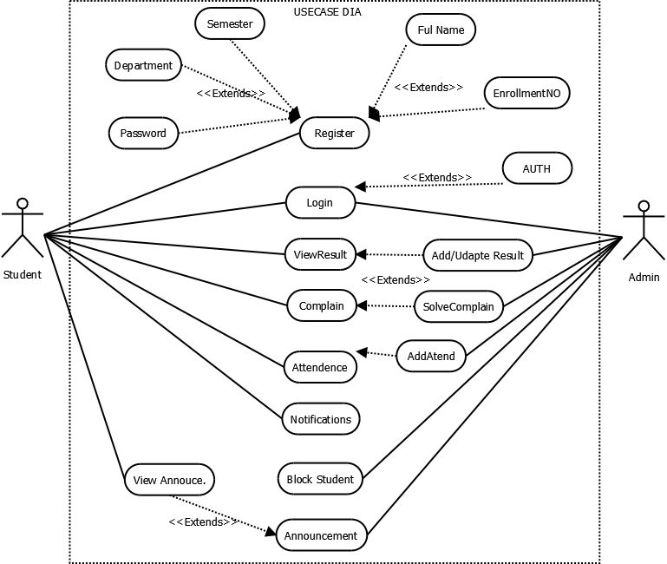

**3.2. Class Diagram:**

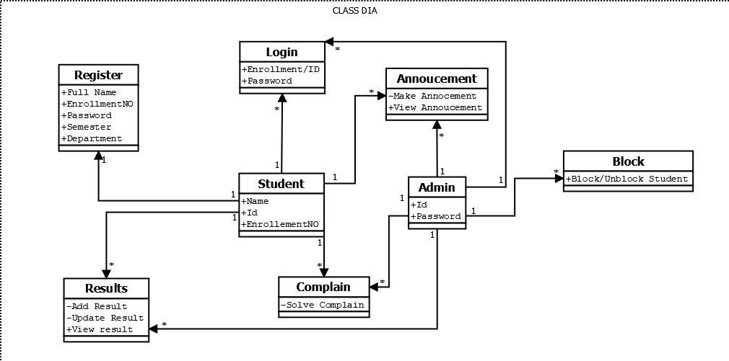

**3.3. Interaction Diagram:**

* Interaction Diagram for Blocking user

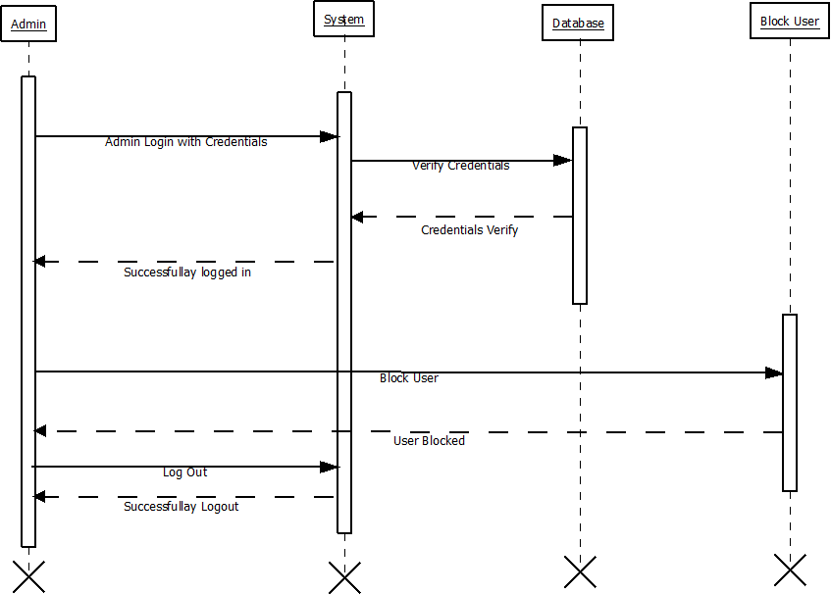

* Interaction Diagram for Announcment :

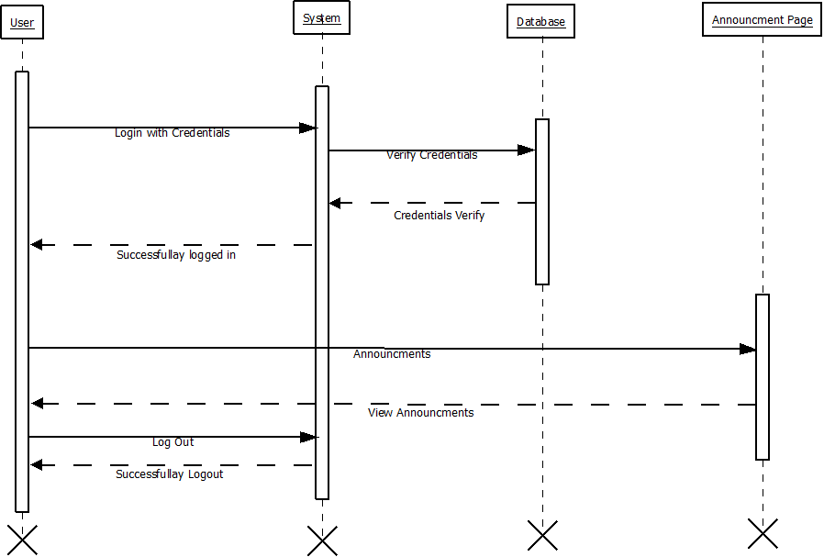



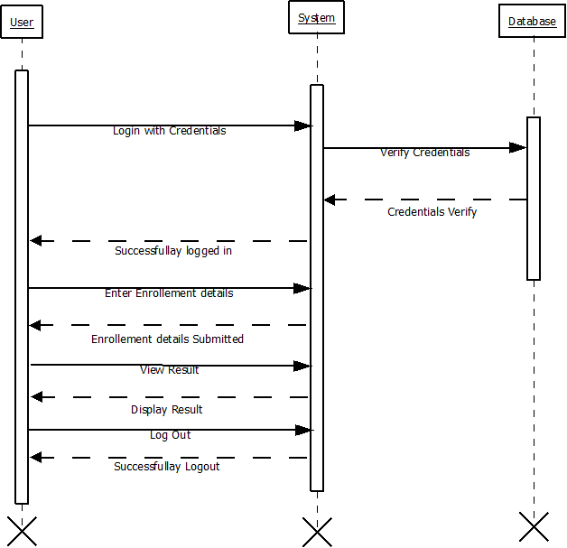

**3.4. Activity Diagram:**

Activity Diagram for View Result :

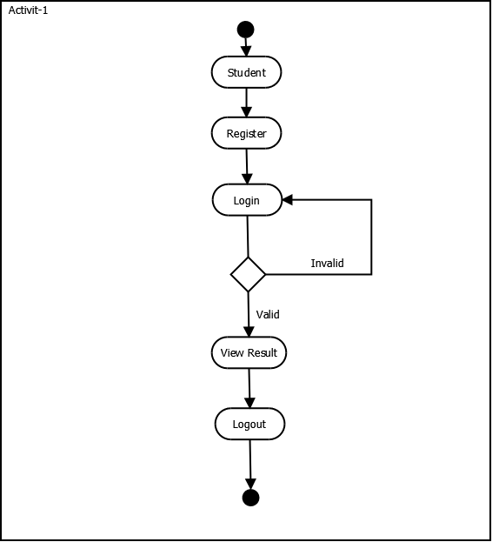

Activity Diagram for Add/Update Result :

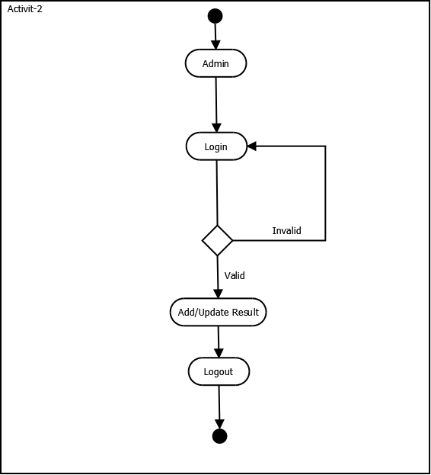

Activity Diagram for Blocking Student:

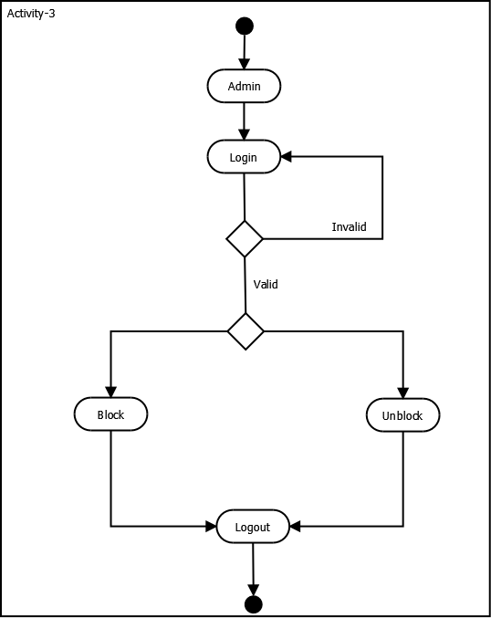

**3.5. Data dictionary:**

|  |  |
| --- | --- |
| **Sr.No** | **Table Name** |
| 1 | Registration/Users |
| 2 | admin |
| 3 | Results |
| 4 | Complains |
| 5 | Announcements |
| 6 | Login History |
| 7 | Notifications |
| 8 | Attendence |

**Table Name:** Student Registration.

**Table Description:** Stores the basic details including name, EnrollmentNo, Password, Confirm Password, Division, Department, Semester and Roll number fill all this fields for Student Registration.

**Table Level Constraints (if any):**

|  |  |  |  |  |
| --- | --- | --- | --- | --- |
| Field Name | Data Type  <with Size> | Constraint | Description | Sample Data |
| user_ID | Char(6) | Primary Key | Branch Code/Identification | 079001 |
| Student_Name | Varchar(30) | Not Null | Name of the Student | Arsh |
| Enrollment_Number | Char(12) | Not Null | Enrollment Number | 2100185 |
| Password | Varchar(30) | Not Null | Password | 1234567 |
| Conform_Password | Varchar(30) | Not Null | Conform Password | 1234567 |
| Division | Varchar(30) | Not Null | Student Division | D |
| Department | Varchar(30) | Not Null | Department | IMCA |
| Semester | Char(12) | Not Null | Semester | 5 |
| Roll_Number | Char(12) | Not Null | Roll Number | 61 |

Example:

**Table Name:** Login History

**Table Description:** Stores the basic details of Login history of Student

|  |  |  |  |  |
| --- | --- | --- | --- | --- |
| Field Name | Data Type (with Size) | Constraint | Description | Sample Data |
| Role | Varchar(30) | **Primary Key** | Role | Admin |
| User_type | Varchar(30) | Not Null | User type | Student |
| Login_Time | Date | Not Null | Login Time | 10:50 AM |
| Task | Varchar(30) | Not Null | Task | Login,Logout |

**Table Name:** Notification

**Table Description:** Stores Every notifications.

|  |  |  |  |  |
| --- | --- | --- | --- | --- |
| Field Name | Data Type (with Size) | Constraint | Description | Sample Data |
| User_ID | Char(16) | **Primary Key** | USER ID | ! |
| Message | Varchar(30) | **Not Null** | Message | Hello |
| Type | Varchar(30) | Not Null | Type | Hello Students |
| Read | Boolean | Not Null | Read |  |
| Created_at | Date | Not Null | Created at | 10-5-2023 |
| Pincode | Char(6) | Not Null | Pincode | 380015 |

**Table Name:** result

**Table Description:** Stores the basic details including Result id, user id, subject, marks Obtained, total marks, and grade.

|  |  |  |  |  |
| --- | --- | --- | --- | --- |
| Field Name | Data Type (with Size) | Constraint | Description | Sample Data |
| Role | Varchar(30) | **Primary Key** | Role | Student |
| result_id | Varchar(30) | Not Null | User type | 30 |
| user_id | Date | Not Null | Login Time | 10-5-2024 |
| subject | Varchar(30) | Not Null | Task | ENGLISH |
| marks_obtained | Char(10) | Not Null | Marks Obtained | 30 |
| total_marks | Varchar(30) | Not Null | Total Marks | 50 |
| grade | Char(10) | Not Null | Grades | A |

**Table Name:** Complaints

**Table Description:** Stores Complain from Student.

|  |  |  |  |  |
| --- | --- | --- | --- | --- |
| Field Name | Data Type (with Size) | Constraint | Description | Sample Data |
| complaint_id | Char(16) | **Foreign Key** | Complain ID | ! |
| user_id | Varchar(30) | **Not Null** | User ID | 1 |
| subject | Varchar(30) | Not Null | Subject | MERN |
| description | Varchar(30) | Not Null | Description | HELLO WORLD |
| status | Varchar(30) | Not Null | Status | Pending |
| created_at | Date | Not Null | Date | 16-1-2025 |
| updated_at | Date | Not Null | Date | 17-1-2025 |

ss

**4. Development:**

**4.1. Coding standards:**

1. Follow naming conventions in variable name and methods name.

2. Give minimum two spaces between operator and operand.

3. Give proper indentation.

* **StudentRegistration BackEnd:**

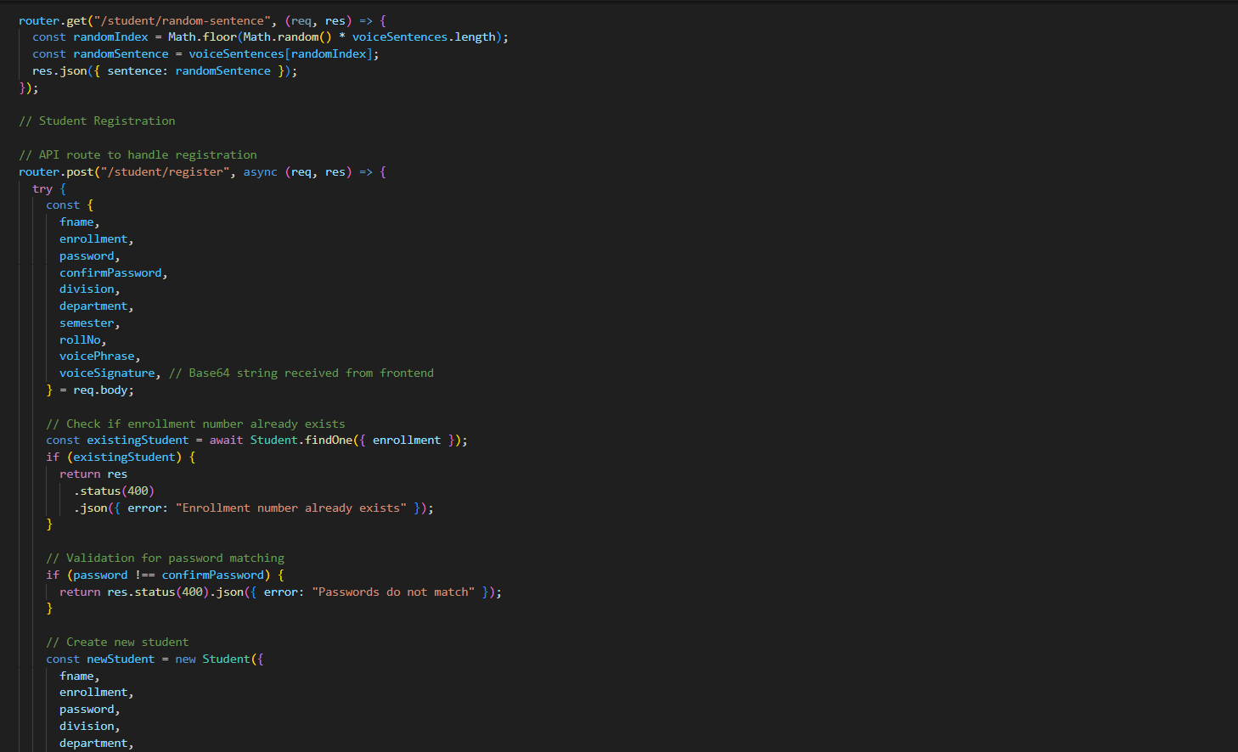

* **CodeStudentLogin:**

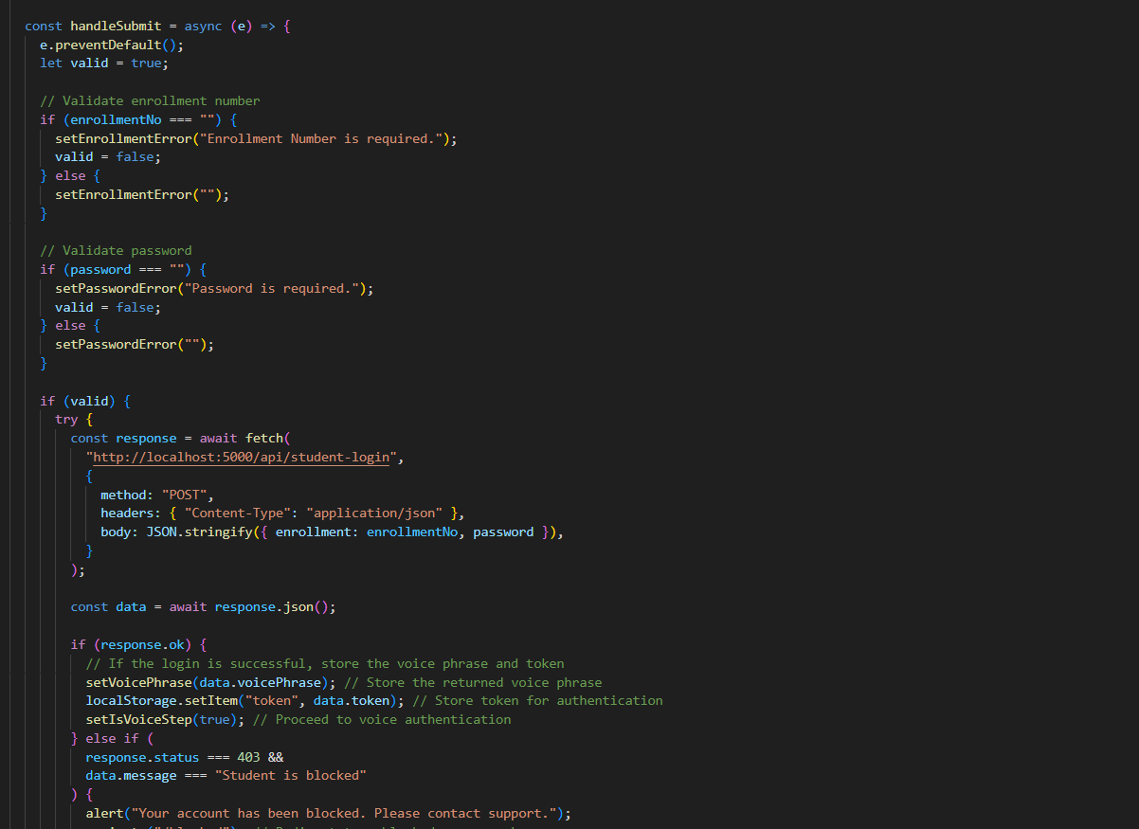

* **StudentLogin BackEnd:**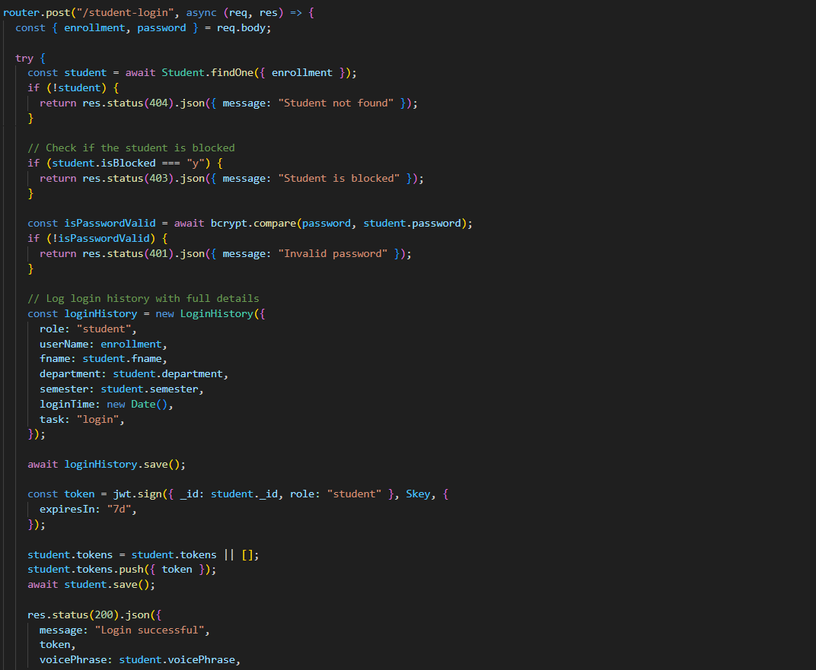

* **Code Admin Panel**:

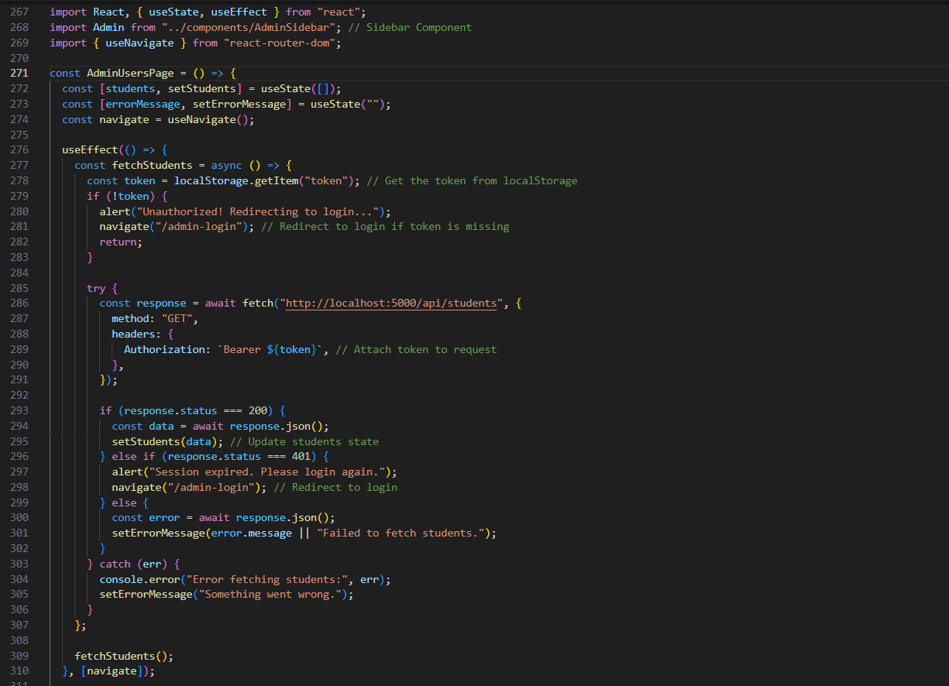

* **Code of Complain page:**

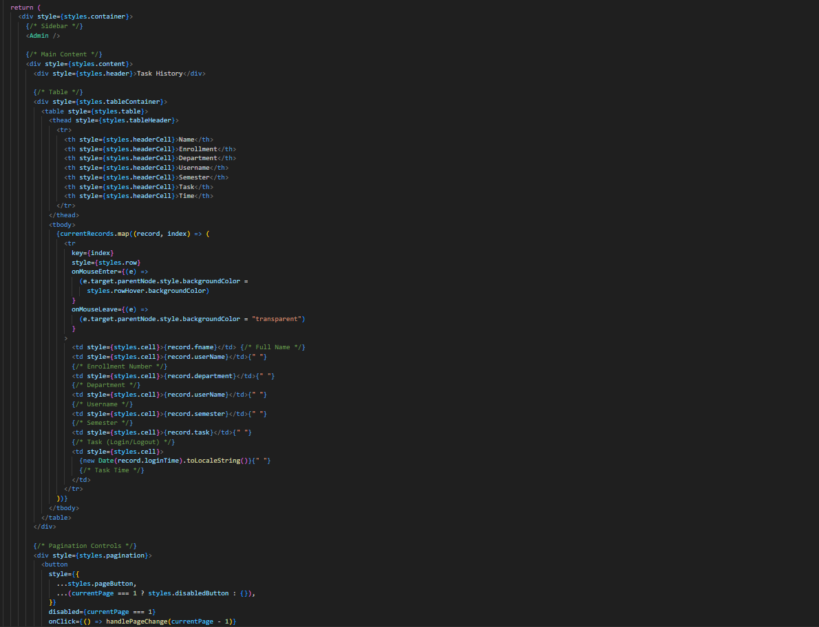

**4.2. Screen shots:**

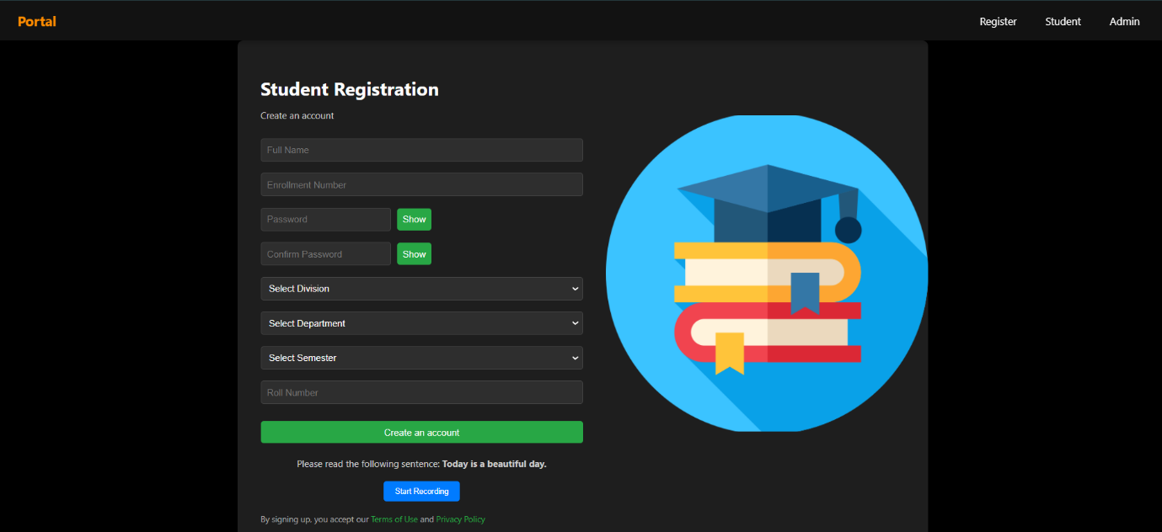

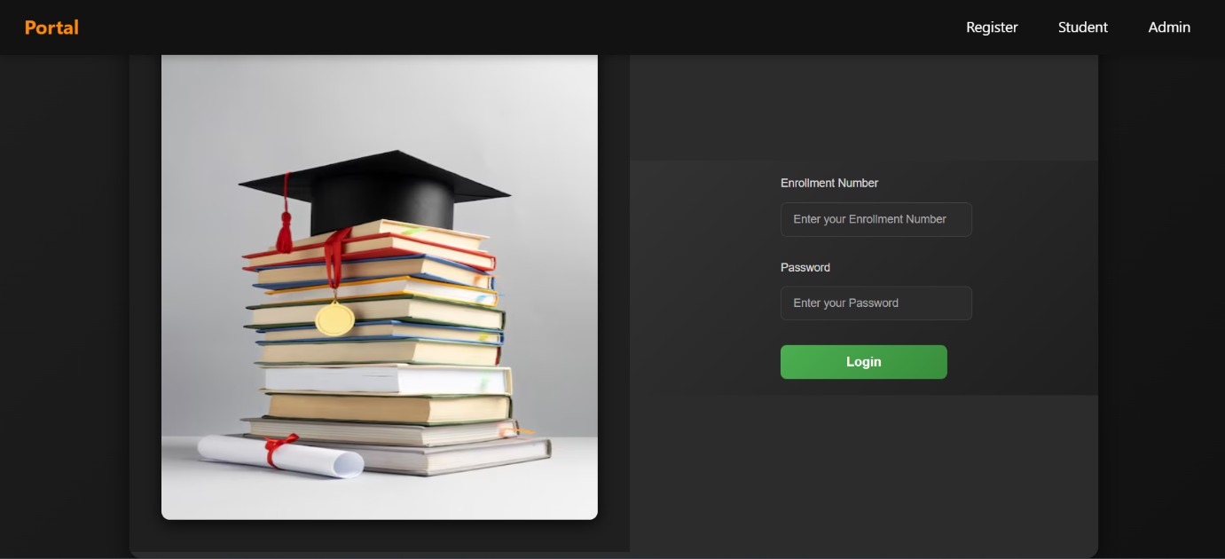

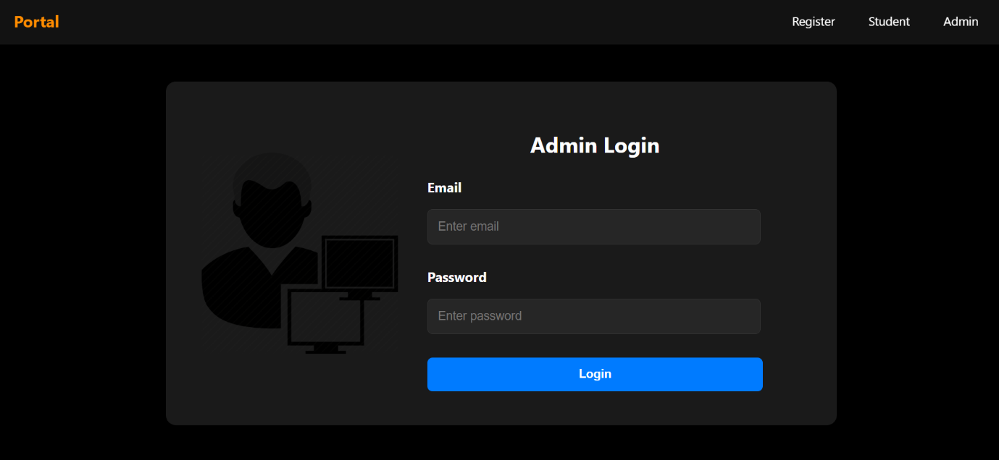

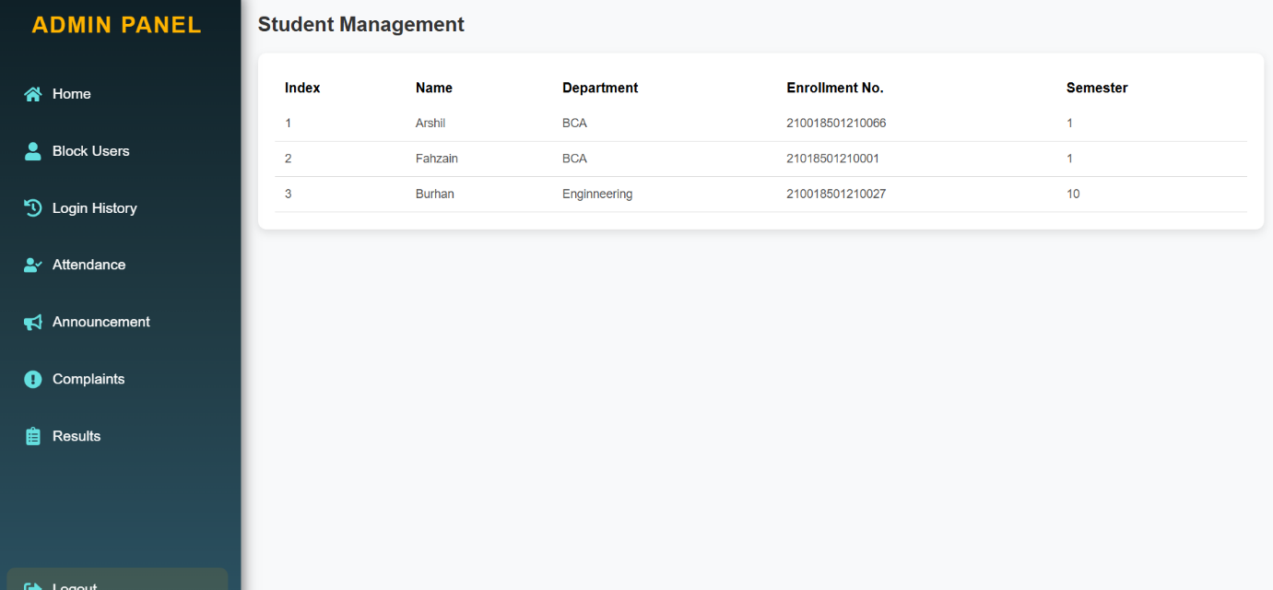

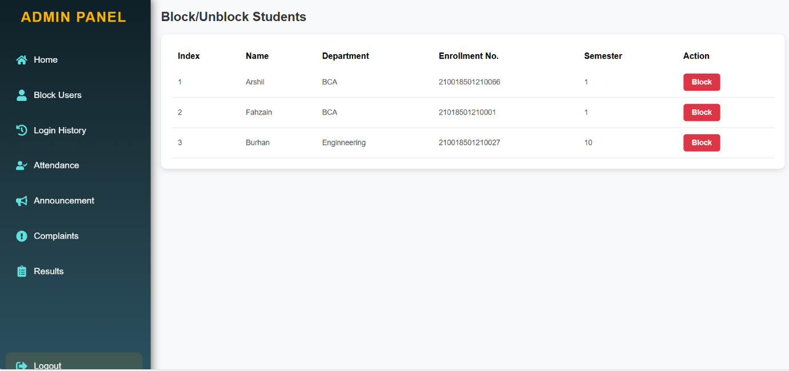

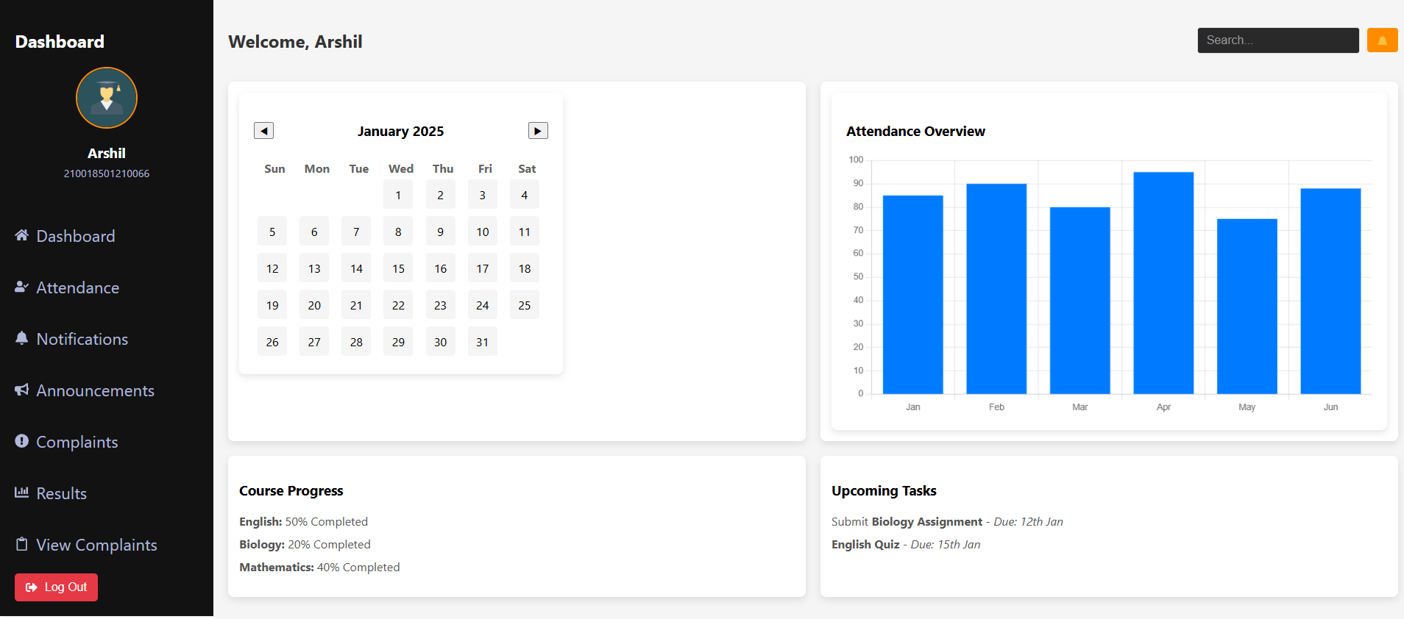

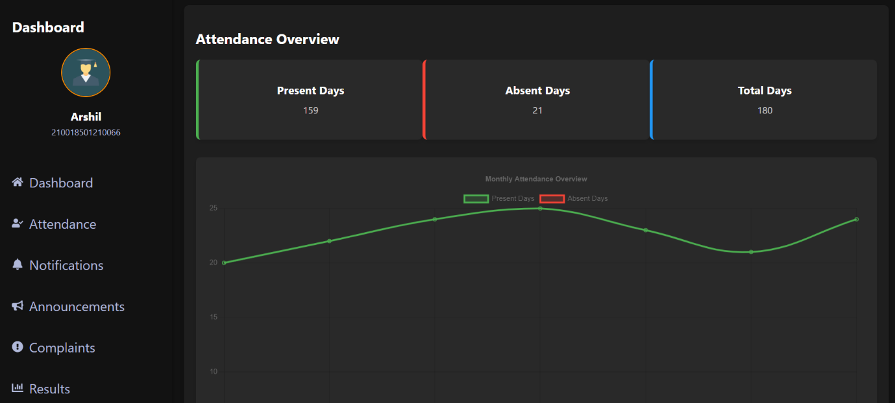

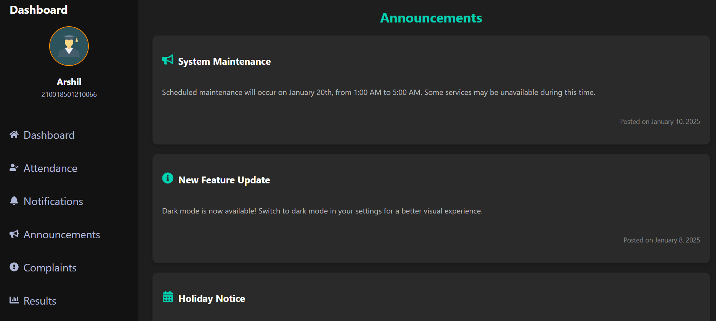

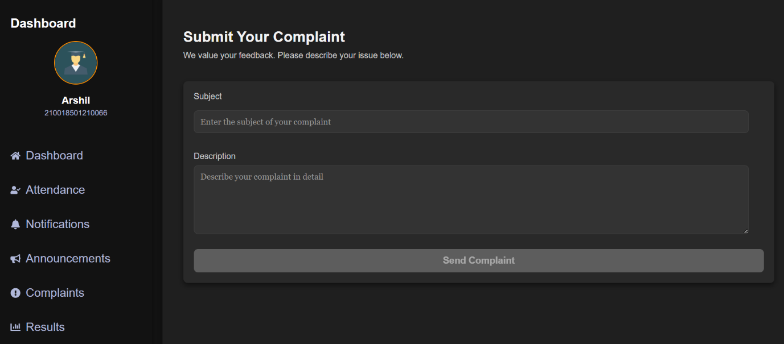

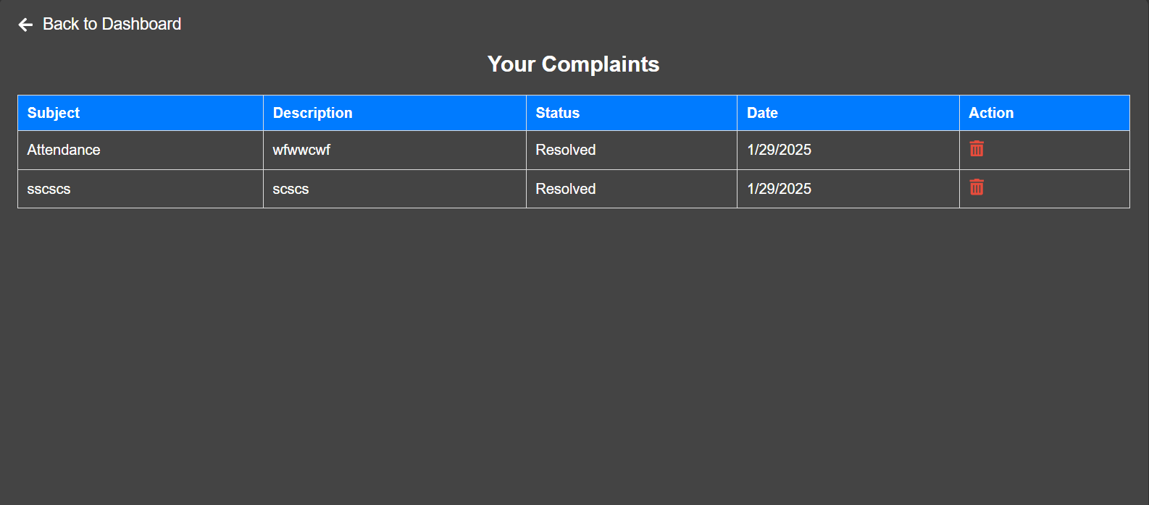

**5. Agile Documentation:**

**5.1 Agile Project Charter**

|  |  |
| --- | --- |
| General Project Information | |
| Project Name | Student Management System |
| Project Champion | Malek Burhaan, Sarjil Sheth, Arsh shaikh |
| Project Sponsor | LJ Institute of Computer Application |
| Project Manager | Prof Harsh |
| Expected Start Date | 06/01/2025 |
| Expected Completion Date | 12/02/2025 |

|  |  |
| --- | --- |
| Project Details | |
| Mission | Our goal is to provide a safe and easy-to-use platform that helps both students and schools manage information. The system makes it easier to track student details, attendance, and grades, while also improving school operations. By allowing better communication between students, teachers, and staff, it aims to support learning and help make better decisions. |
| Vision | Our vision is to build a simple and effective platform that helps schools easily manage student information and supports better communication. We want to make it easier for students and staff to work together, improving the overall learning experience and making University operations run smoothly. |
| Scope | The Student Management System will help schools keep track of student info like attendance, grades, and personal details. It will also let teachers and staff manage academic performance and send updates to students and parents. The system will be easy to use, safe, and designed to fit the needs of University of all sizes. |
| Date | 06/01/2025 |

**5.2 Agile Roadmap / Schedule:**

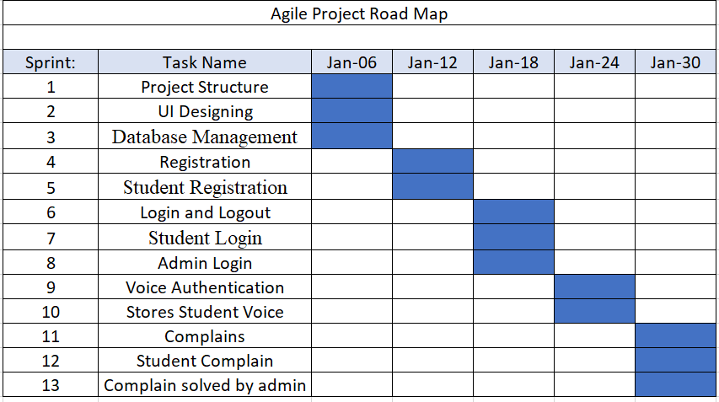

**5.3 Agile Project Plan:**

|  |  |  |  |  |
| --- | --- | --- | --- | --- |
| **Task Name** | **Duration** | **Start** | **Finish** | **Status** |
| **Sprint#1 : Project Structure** | 2d | 06/01/2025 | 08/01/2025 | Completed |
| UI Designing | 1d | 08/01/2025 | 09/01/2025 | Completed |
| Database Management | 2d | 09/01/2025 | 11/01/2025 | Completed |
| **Sprint#2 : Registration** | 1d | 11/01/2025 | 12/01/2025 | Completed |
| Student Registration | 1d | 12/01/2025 | 13/01/2025 | Completed |
| **Sprint#3 : Login and Logout** | 1d | 13/01/2025 | 14/01/2025 | Completed |
| Student Login | 1d | 14/01/2025 | 15/01/2025 | Completed |
| Admin Login | 1d | 15/01/2025 | 16/01/2025 | Completed |
| **Sprint#4 : Voice Authetication** | 3d | 16/01/2025 | 19/01/2025 | Completed |
| Stores Student voice | 2d | 19/01/2025 | 21/01/2025 | Completed |
| **Sprint#5 : Complains** | 1d | 21/01/2025 | 22/01/2025 | Completed |
| Students Complains | 1d | 22/01/2025 | 23/01/2025 | Completed |
| Complains Solved by admin | 1d | 23/01/2025 | 24/01/2025 | Completed |

**5.4 Agile User Story:**

|  |  |  |  |
| --- | --- | --- | --- |
| **User Story ID** | **As a (type of user)** | **I want to (perform some task)** | **So that I can (achieve some goal)** |
| **1** | Admin | Manage Login Module | Ensure that validate Students can join |
| **2** | Admin | Manage Courses | Insert, Update Delete and View the Courses |
| **3** | Admin | Manage Announcements | Make announcements for the students |
| **4** | Student | View Results | View Results |
| **5** | Student | Select Results | Select the Results |
| **6** | Student | Make complains | Complains abouts any problems that student is facing so that admin can solved it |
| **7** | Admin | Add Attendence | Add attendance for student |

**5.5 Agile Release Plan:**

|  |  |  |  |  |
| --- | --- | --- | --- | --- |
| **Task Name** | **Duration** | **Start** | **Finish** | **Status** |
| **Sprint#1 : Project Structure** | 2d | 06/01/2025 | 08/01/2025 | Completed |
| UI Designing | 1d | 08/01/2025 | 09/01/2025 | Completed |
| Database Management | 2d | 09/01/2025 | 11/01/2025 | Completed |
| **Sprint#2 : Registration** | 1d | 11/01/2025 | 12/01/2025 | Completed |
| Student Registration | 1d | 12/01/2025 | 13/01/2025 | Completed |
| **Sprint#3 : Login and Logout** | 1d | 13/01/2025 | 14/01/2025 | Completed |
| Student Login | 1d | 14/01/2025 | 15/01/2025 | Completed |
| Admin Login | 1d | 15/01/2025 | 16/01/2025 | Completed |
| **Sprint#4 : Voice Authetication** | 3d | 16/01/2025 | 19/01/2025 | Completed |
| Stores Student voice | 2d | 19/01/2025 | 21/01/2025 | Completed |
| **Sprint#5 : Complains** | 1d | 21/01/2025 | 22/01/2025 | Completed |
| Students Complains | 1d | 22/01/2025 | 23/01/2025 | Completed |
| Complains Solved by admin | 1d | 23/01/2025 | 24/01/2025 | Completed |

**5.6 Agile Sprint Backlog:**

|  |  |  |  |  |  |
| --- | --- | --- | --- | --- | --- |
| **Task Name** | **Story** | **Sprint Ready** | **Priority** | **Status** | **Story Point** |
| **Sprint#1: Project Structure** | Yes | Yes | High | Completed | 9 |
| UI Designing | Yes | Yes | High | Completed | 10 |
| Database Management | Yes | Yes | High | Completed | 9 |
| **Sprint#2 : Registration** | Yes | Yes | High | Completed | 9 |
| Student Registration | Yes | Yes | High | Completed | 8 |
| **Sprint#3 : Login and Logout** | Yes | Yes | High | Completed | 8 |
| Student Login | Yes | Yes | High | Completed | 8 |
| Admin Login | Yes | Yes | High | Completed | 8 |
| **Sprint#4 : Voice Authenticaton** | Yes | Yes | High | Completed | 10 |
| Student store voice | Yes | Yes | High | Completed | 10 |

**5.7 Agile Test Plan:**

|  |  |
| --- | --- |
| **Test Case ID : 101** | **Test Case Name : Customer Login** |
| **Designed by : Buri** | **Design Date :- 07/04/2023** |
| **Module Name : User Login** | **Sub Module Name : Login** |
| **Executed by : Buri** | **Execution Date : 12/04/2023** |
| **Brief Description : User Login**  **(wit Data : “EnrollmentNo : 21018501210001 & password:1234”)** | **Test Priority (Low/Medium/High) : High** |
| **Pre-Conditions: User Must Registered & have** | **Correct Username & Password.** |
| **Dependencies : None** |  |

|  |  |  |  |  |  |
| --- | --- | --- | --- | --- | --- |
| **Test Step** | **Test Data** | **Expected Result** | **Actual Result** | **Status (Pass/Fail)** | **Remarks** |
| 1 | **EnrollementNO:** 2101850121001  **Password:** 1234  **Voice Authentication:** Page | Successfully login & redirect to  Home Page. | Login Successful. | Pass | None |
| 2 | **Email:** t1@g.com  **Password:** 1234 | Show “Invalid Credentials.” | Login Not Successful | Fail | Need to Show Error  Message. |

|  |  |
| --- | --- |
| **Test Case ID : 102** | **Test Case Name : User Registration** |
| **Designed by : Sarjil Sheth** | **Design Date : 12/01/2025** |
| **Module Name : User Registration** | **Sub Module Name : Register** |
| **Executed by : Sarjil Sheth** | **Execution Date : 13/01/2025** |
| **Brief Description: User Registration page for the new user. User needs to provide**  **the correct details for Registration.** | **Test Priority (Low/Medium/High) : High** |
| **Pre-conditions : None** | |
| **Dependencies: Username & Password are store & fetch from auth_user Table.** | |

|  |  |  |  |  |  |
| --- | --- | --- | --- | --- | --- |
| **Test Step** | **Test Data** | **Expected Result** | **Actual Result** | **Status (Pass/Fail)** | **Remar ks** |
| 1 | **First Name:** Sarjil  **Last Name:** Sheth **EnrollmentNo:**2101 **Password:** 1234 **Confirm Password:**  1234 | Successfully Registered & Redirect to Login Page. | Registered Successfully. | Pass | Redirect to login Page. |
| 2 | **First Name:** nisheeth **Last Name:** bhatt **Email:** [nisheeth@gmail.com](mailto:nisheeth@gmail.com) **Password:** 1234 **Confirm Password:**  12345 | Show Error Message as “Password & Confirm  Password must be Equal” | Not Registered & remain in Registration page. | Fail | None |

|  |  |
| --- | --- |
| **Test Case ID : 103** | **Test Case Name : View Result** |
| **Designed by : Sarjil Sheth** | **Design Date : 12/01/2025** |
| **Module Name : User Registration** | **Sub Module Name : Register** |
| **Executed by : Sarjil Sheth** | **Execution Date : 13/01/2025** |
| **Brief Description: View Result page for the user. User needs to provide**  **the correct details for Login.** | **Test Priority (Low/Medium/High) : High** |
| **Pre-conditions : None** | |
| **Dependencies: Username & Password are store & fetch from auth_user Table.** | |

|  |  |  |  |  |  |
| --- | --- | --- | --- | --- | --- |
| **Test** | **Test Step** | **Action** | **Expected Result** | **Actual Result** | **Status (Pass/Fail)** |
| 1 | Click on Login page | Open  Result details page | Can see the result | Can see the result | Pass |
| 2 | Fill Enroll- mentNO Details. | Taking Valid  details | Validation of input data | Validation of input data | Pass |
| 3 | Voice Authentica--tion | Click on start  recording button | Read the correct Phrase | Read the correct Phrase | Pass |

|  |  |
| --- | --- |
| **Test Case ID : 104** | **Test Case Name : Cart** |
| **Designed by : Munish Prajapati** | **Design Date :** 20/04/2023 |
| **Module Name : Course Module** | **Sub Module Name :** Add Course |
| **Executed by : Nisheeth bhatt** | **Execution Date : 13/04/2023** |
| **Brief Description: User can Add the**  **Courses** | **Test Priority (Low/Medium/High) :** High |
| **Pre-conditions : User must be Logged in.** | |
| **Dependencies : None** | |

|  |  |  |  |  |  |
| --- | --- | --- | --- | --- | --- |
| **Test** | **Test Step** | **Action** | **Expected Result** | **Actual Result** | **Status (Pass/Fail)** |
| 1 | Click on add course Button | Course  should be added | Course should be added and  display | Course should not be added | Fail |
| 2 | Click on add course Button | Course  should be added | Course should be added and display | Course should be added to display | Pass |
| 3 | Click on(+) Increase Button | Added Course count Increase | Course count Increase add same item multiple time | Course count Increase add same  Course multiple time | Pass |
| 4 | Click on(-) Increase Button | Added Course  count Decrease &  Delete | Course count Decrease & Delete/remove | Course count Decrease & Delete/remove | Pass |
| **5** | Click on Course Button | Add the Course | able to add multiple Course | able to add multiple Course | Pass |

**5.8 Earned-Value Burned Chart:**

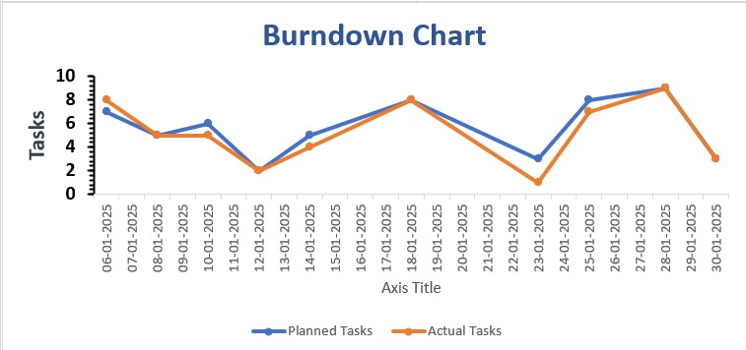

**6. Proposed Enhancement:**

* We try to implement SMS functionality in our system like sending weakly student reports.
* Try to implement online payment facility.
* Try to implement automated testing functionality.
* Make a common web application that multiple courses for student who can use it.

**7. Conclusion:**

While developing this project we have learnt a lot of thing about E-learning learning work cycle and many other things. Our Goal was to design a reusable, scalable and extensible digital E-learning website. This application provide courses at low cost. This application helps in significant time and database management and for better customer satisfaction.

Here, we need to learn Flutter technology to develop this application. Also we learn PHP, Laravel and my Sql to make our Project even Better.

Building of project has given a precise knowledge about how Flutter framework used to develop a web application, how it connects with firebase to access data and how the data and web pages are modified provide to user with this system

**8. Bibliography:**

* [www.google.com](http://www.google.com)
* www.learnvern.com
* [www.tutorialspoint.com](http://www.tutorialspoint.com)
* www.learnvern.com
* [www.w3school.com](http://www.w3school.com)
* www.stackoverflow.com